# File Upload Guide

Your homework on this exercise will not be in the Judge system. Instead, you will have to upload a **zip file** to the SoftUni website.

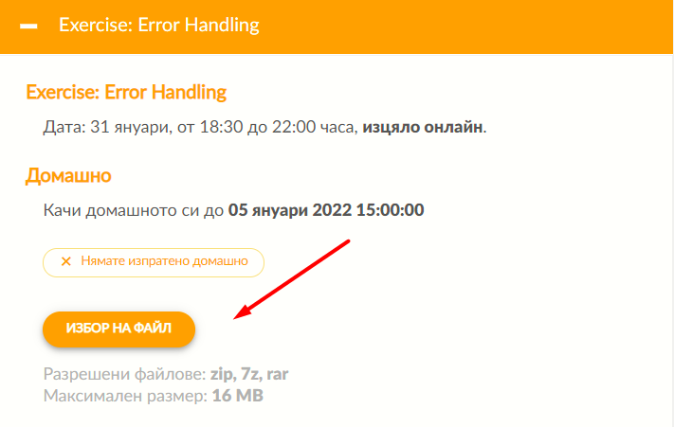You need to submit your project's folder containing your solutions to the exercise's problems, excluding the .idea and venv folders. If you want to change your solution for some of the problems, you must upload a new zip file. The most recent uploaded solutions will be kept.

You will have **limited time** for uploading your homework. If you've **successfully** **uploaded** it to the system, you will see the **following button** from where you could download your **homework**:

**After the period** for uploading homework **ends**, it will start a **new period** for **reviewing** and **grading** **colleagues' homework**. Your homework will be scored to the 5% bonus to your grade only if you review and grade at least **three** **homework** submitted by your colleagues.

When you **click** on the button to grade homework, the system will redirect to a **review page**. There, you will be able to **download** a colleague's file at random. You **cannot continue** to the next colleague's homework until **you grade and review** the given one.

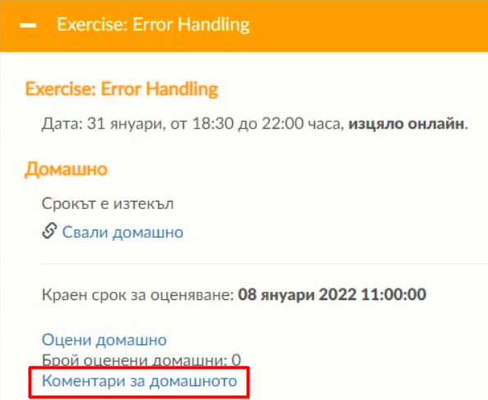Also, you will be able to **see** **all reviews** from your colleagues and **to evaluate** **them** for correctness and usefulness:

You will be **redirected** to the **following page**:

